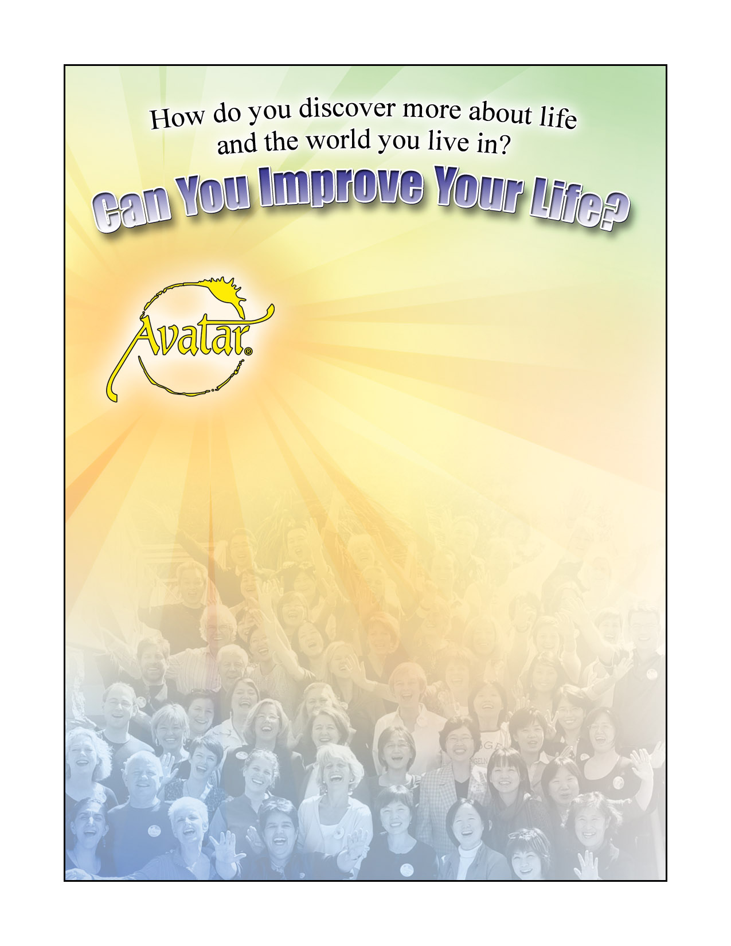
Free Intro to Avatar

Sunday, Feb. 28 2010
3-6 p.m.
At The One Center
149 East Pearl Street

Call Tina for details or to join us:
307-413-3494

Get Started With
The Avatar® Course.

The Avatar Course is about your beliefs and your perspectives. It is a series of experiential exercises that enables you to rediscover your
self and align your consciousness with what
you want to achieve. You will experience
your own unique insights and revelations.
“Avatar teaches the use of proven navigational tools that can be used, in harmony with your own integrity, to pass safely across the uncharted turbulence of the mind into the region of the soul.”
– Harry Palmer, author
of the Avatar materials
Avatar® is a registered trademark of Star’s Edge, Inc. All rights reserved.

